30/11/23, 16:02 Cloud Digital Leader Exam – Free Actual Q&As, Page 1 | ExamTopics 

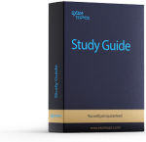



https://www.examtopics.com/exams/google/cloud-digital-leader/custom-view/ 1/80

30/11/23, 16:02 Cloud Digital Leader Exam – Free Actual Q&As, Page 1 | ExamTopics

https://www.examtopics.com/exams/google/cloud-digital-leader/custom-view/ 2/80

30/11/23, 16:02 Cloud Digital Leader Exam – Free Actual Q&As, Page 1 | ExamTopics

https://www.examtopics.com/exams/google/cloud-digital-leader/custom-view/ 3/80

30/11/23, 16:02 Cloud Digital Leader Exam – Free Actual Q&As, Page 1 | ExamTopics

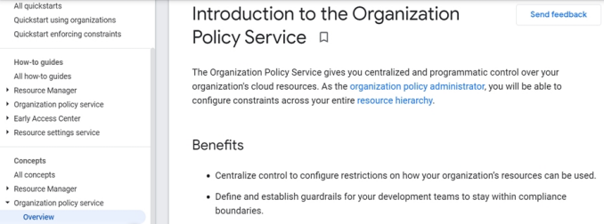https://www.examtopics.com/exams/google/cloud-digital-leader/custom-view/ 4/80

30/11/23, 16:02 Cloud Digital Leader Exam – Free Actual Q&As, Page 1 | ExamTopics

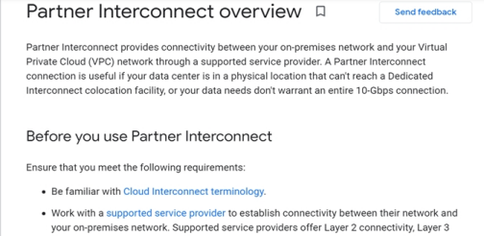

https://www.examtopics.com/exams/google/cloud-digital-leader/custom-view/ 5/80

30/11/23, 16:02 Cloud Digital Leader Exam – Free Actual Q&As, Page 1 | ExamTopics

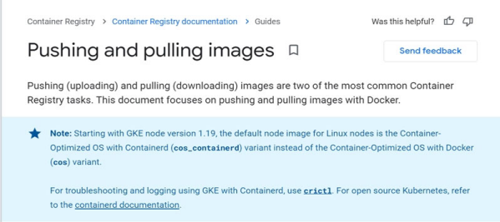https://www.examtopics.com/exams/google/cloud-digital-leader/custom-view/ 6/80

30/11/23, 16:02 Cloud Digital Leader Exam – Free Actual Q&As, Page 1 | ExamTopics

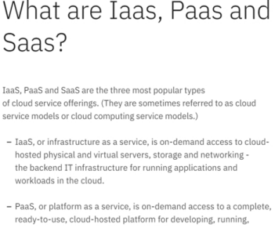

https://www.examtopics.com/exams/google/cloud-digital-leader/custom-view/ 7/80

30/11/23, 16:02 Cloud Digital Leader Exam – Free Actual Q&As, Page 1 | ExamTopics

https://www.examtopics.com/exams/google/cloud-digital-leader/custom-view/ 8/80

30/11/23, 16:02 Cloud Digital Leader Exam – Free Actual Q&As, Page 1 | ExamTopics

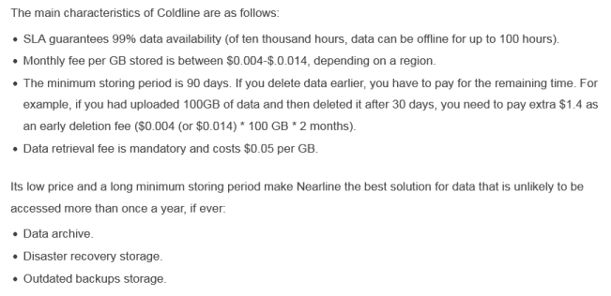https://www.examtopics.com/exams/google/cloud-digital-leader/custom-view/ 9/80

30/11/23, 16:02 Cloud Digital Leader Exam – Free Actual Q&As, Page 1 | ExamTopics

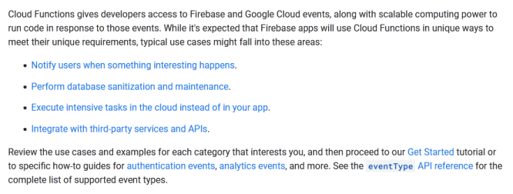https://www.examtopics.com/exams/google/cloud-digital-leader/custom-view/ 10/80

30/11/23, 16:02 Cloud Digital Leader Exam – Free Actual Q&As, Page 1 | ExamTopics

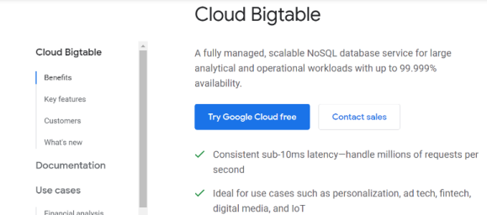

https://www.examtopics.com/exams/google/cloud-digital-leader/custom-view/ 11/80

30/11/23, 16:02 Cloud Digital Leader Exam – Free Actual Q&As, Page 1 | ExamTopics

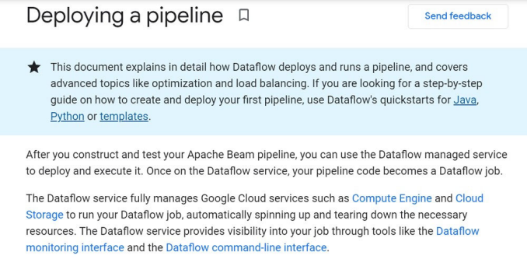https://www.examtopics.com/exams/google/cloud-digital-leader/custom-view/ 12/80

30/11/23, 16:02 Cloud Digital Leader Exam – Free Actual Q&As, Page 1 | ExamTopics

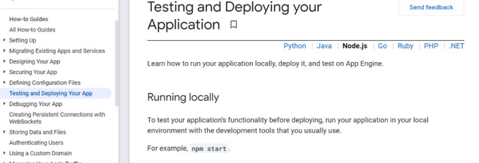https://www.examtopics.com/exams/google/cloud-digital-leader/custom-view/ 13/80

30/11/23, 16:02 Cloud Digital Leader Exam – Free Actual Q&As, Page 1 | ExamTopics

https://www.examtopics.com/exams/google/cloud-digital-leader/custom-view/ 14/80

30/11/23, 16:02 Cloud Digital Leader Exam – Free Actual Q&As, Page 1 | ExamTopics

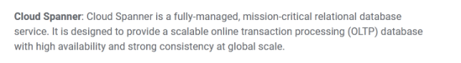

https://www.examtopics.com/exams/google/cloud-digital-leader/custom-view/ 15/80

30/11/23, 16:02 Cloud Digital Leader Exam – Free Actual Q&As, Page 1 | ExamTopics

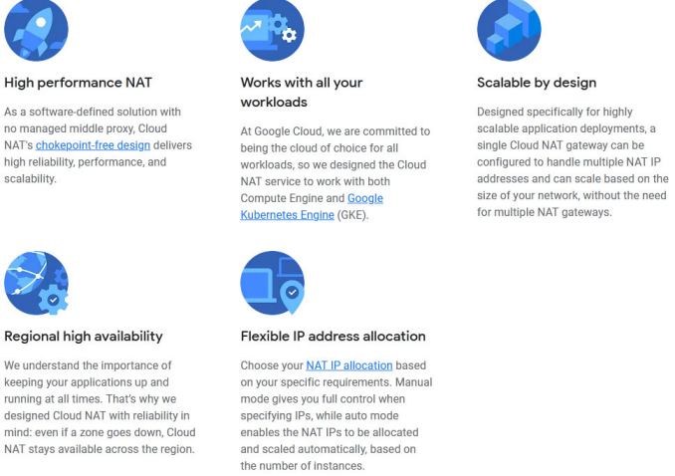https://www.examtopics.com/exams/google/cloud-digital-leader/custom-view/ 16/80

30/11/23, 16:02 Cloud Digital Leader Exam – Free Actual Q&As, Page 1 | ExamTopics

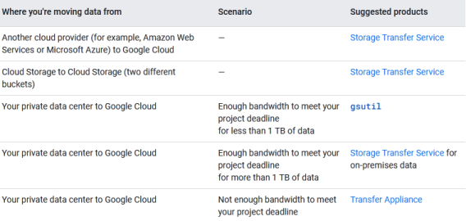

https://www.examtopics.com/exams/google/cloud-digital-leader/custom-view/ 17/80

30/11/23, 16:02 Cloud Digital Leader Exam – Free Actual Q&As, Page 1 | ExamTopics

https://www.examtopics.com/exams/google/cloud-digital-leader/custom-view/ 18/80

30/11/23, 16:02 Cloud Digital Leader Exam – Free Actual Q&As, Page 1 | ExamTopics

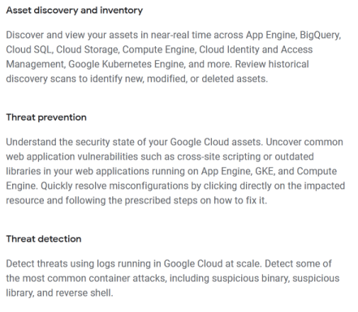

https://www.examtopics.com/exams/google/cloud-digital-leader/custom-view/ 19/80

30/11/23, 16:02 Cloud Digital Leader Exam – Free Actual Q&As, Page 1 | ExamTopics

https://www.examtopics.com/exams/google/cloud-digital-leader/custom-view/ 20/80

30/11/23, 16:02 Cloud Digital Leader Exam – Free Actual Q&As, Page 1 | ExamTopics

https://www.examtopics.com/exams/google/cloud-digital-leader/custom-view/ 21/80

30/11/23, 16:02 Cloud Digital Leader Exam – Free Actual Q&As, Page 1 | ExamTopics

https://www.examtopics.com/exams/google/cloud-digital-leader/custom-view/ 22/80

30/11/23, 16:02 Cloud Digital Leader Exam – Free Actual Q&As, Page 1 | ExamTopics

https://www.examtopics.com/exams/google/cloud-digital-leader/custom-view/ 23/80

30/11/23, 16:02 Cloud Digital Leader Exam – Free Actual Q&As, Page 1 | ExamTopics

https://www.examtopics.com/exams/google/cloud-digital-leader/custom-view/ 24/80

30/11/23, 16:02 Cloud Digital Leader Exam – Free Actual Q&As, Page 1 | ExamTopics

https://www.examtopics.com/exams/google/cloud-digital-leader/custom-view/ 25/80

30/11/23, 16:02 Cloud Digital Leader Exam – Free Actual Q&As, Page 1 | ExamTopics

https://www.examtopics.com/exams/google/cloud-digital-leader/custom-view/ 26/80

30/11/23, 16:02 Cloud Digital Leader Exam – Free Actual Q&As, Page 1 | ExamTopics

https://www.examtopics.com/exams/google/cloud-digital-leader/custom-view/ 27/80

30/11/23, 16:02 Cloud Digital Leader Exam – Free Actual Q&As, Page 1 | ExamTopics

https://www.examtopics.com/exams/google/cloud-digital-leader/custom-view/ 28/80

30/11/23, 16:02 Cloud Digital Leader Exam – Free Actual Q&As, Page 1 | ExamTopics

https://www.examtopics.com/exams/google/cloud-digital-leader/custom-view/ 29/80

30/11/23, 16:02 Cloud Digital Leader Exam – Free Actual Q&As, Page 1 | ExamTopics

https://www.examtopics.com/exams/google/cloud-digital-leader/custom-view/ 30/80

30/11/23, 16:02 Cloud Digital Leader Exam – Free Actual Q&As, Page 1 | ExamTopics

https://www.examtopics.com/exams/google/cloud-digital-leader/custom-view/ 31/80

30/11/23, 16:02 Cloud Digital Leader Exam – Free Actual Q&As, Page 1 | ExamTopics

https://www.examtopics.com/exams/google/cloud-digital-leader/custom-view/ 32/80

30/11/23, 16:02 Cloud Digital Leader Exam – Free Actual Q&As, Page 1 | ExamTopics

https://www.examtopics.com/exams/google/cloud-digital-leader/custom-view/ 33/80

30/11/23, 16:02 Cloud Digital Leader Exam – Free Actual Q&As, Page 1 | ExamTopics 

ג ג

https://www.examtopics.com/exams/google/cloud-digital-leader/custom-view/ 34/80

30/11/23, 16:02 Cloud Digital Leader Exam – Free Actual Q&As, Page 1 | ExamTopics

https://www.examtopics.com/exams/google/cloud-digital-leader/custom-view/ 35/80

30/11/23, 16:02 Cloud Digital Leader Exam – Free Actual Q&As, Page 1 | ExamTopics



https://www.examtopics.com/exams/google/cloud-digital-leader/custom-view/ 36/80

30/11/23, 16:02 Cloud Digital Leader Exam – Free Actual Q&As, Page 1 | ExamTopics

https://www.examtopics.com/exams/google/cloud-digital-leader/custom-view/ 37/80

30/11/23, 16:02 Cloud Digital Leader Exam – Free Actual Q&As, Page 1 | ExamTopics

https://www.examtopics.com/exams/google/cloud-digital-leader/custom-view/ 38/80

30/11/23, 16:02 Cloud Digital Leader Exam – Free Actual Q&As, Page 1 | ExamTopics

https://www.examtopics.com/exams/google/cloud-digital-leader/custom-view/ 39/80

30/11/23, 16:02 Cloud Digital Leader Exam – Free Actual Q&As, Page 1 | ExamTopics

https://www.examtopics.com/exams/google/cloud-digital-leader/custom-view/ 40/80

30/11/23, 16:02 Cloud Digital Leader Exam – Free Actual Q&As, Page 1 | ExamTopics

https://www.examtopics.com/exams/google/cloud-digital-leader/custom-view/ 41/80

30/11/23, 16:02 Cloud Digital Leader Exam – Free Actual Q&As, Page 1 | ExamTopics

https://www.examtopics.com/exams/google/cloud-digital-leader/custom-view/ 42/80

30/11/23, 16:02 Cloud Digital Leader Exam – Free Actual Q&As, Page 1 | ExamTopics

https://www.examtopics.com/exams/google/cloud-digital-leader/custom-view/ 43/80

30/11/23, 16:02 Cloud Digital Leader Exam – Free Actual Q&As, Page 1 | ExamTopics

https://www.examtopics.com/exams/google/cloud-digital-leader/custom-view/ 44/80

30/11/23, 16:02 Cloud Digital Leader Exam – Free Actual Q&As, Page 1 | ExamTopics

https://www.examtopics.com/exams/google/cloud-digital-leader/custom-view/ 45/80

30/11/23, 16:02 Cloud Digital Leader Exam – Free Actual Q&As, Page 1 | ExamTopics

https://www.examtopics.com/exams/google/cloud-digital-leader/custom-view/ 46/80

30/11/23, 16:02 Cloud Digital Leader Exam – Free Actual Q&As, Page 1 | ExamTopics

https://www.examtopics.com/exams/google/cloud-digital-leader/custom-view/ 47/80

30/11/23, 16:02 Cloud Digital Leader Exam – Free Actual Q&As, Page 1 | ExamTopics

https://www.examtopics.com/exams/google/cloud-digital-leader/custom-view/ 48/80

30/11/23, 16:02 Cloud Digital Leader Exam – Free Actual Q&As, Page 1 | ExamTopics

https://www.examtopics.com/exams/google/cloud-digital-leader/custom-view/ 49/80

30/11/23, 16:02 Cloud Digital Leader Exam – Free Actual Q&As, Page 1 | ExamTopics

https://www.examtopics.com/exams/google/cloud-digital-leader/custom-view/ 50/80

30/11/23, 16:02 Cloud Digital Leader Exam – Free Actual Q&As, Page 1 | ExamTopics

https://www.examtopics.com/exams/google/cloud-digital-leader/custom-view/ 51/80

30/11/23, 16:02 Cloud Digital Leader Exam – Free Actual Q&As, Page 1 | ExamTopics

https://www.examtopics.com/exams/google/cloud-digital-leader/custom-view/ 52/80

30/11/23, 16:02 Cloud Digital Leader Exam – Free Actual Q&As, Page 1 | ExamTopics

https://www.examtopics.com/exams/google/cloud-digital-leader/custom-view/ 53/80

30/11/23, 16:02 Cloud Digital Leader Exam – Free Actual Q&As, Page 1 | ExamTopics

https://www.examtopics.com/exams/google/cloud-digital-leader/custom-view/ 54/80

30/11/23, 16:02 Cloud Digital Leader Exam – Free Actual Q&As, Page 1 | ExamTopics

https://www.examtopics.com/exams/google/cloud-digital-leader/custom-view/ 55/80

30/11/23, 16:02 Cloud Digital Leader Exam – Free Actual Q&As, Page 1 | ExamTopics

https://www.examtopics.com/exams/google/cloud-digital-leader/custom-view/ 56/80

30/11/23, 16:02 Cloud Digital Leader Exam – Free Actual Q&As, Page 1 | ExamTopics

https://www.examtopics.com/exams/google/cloud-digital-leader/custom-view/ 57/80

30/11/23, 16:02 Cloud Digital Leader Exam – Free Actual Q&As, Page 1 | ExamTopics

https://www.examtopics.com/exams/google/cloud-digital-leader/custom-view/ 58/80

30/11/23, 16:02 Cloud Digital Leader Exam – Free Actual Q&As, Page 1 | ExamTopics

https://www.examtopics.com/exams/google/cloud-digital-leader/custom-view/ 59/80

30/11/23, 16:02 Cloud Digital Leader Exam – Free Actual Q&As, Page 1 | ExamTopics

~~ג ג~~

https://www.examtopics.com/exams/google/cloud-digital-leader/custom-view/ 60/80

30/11/23, 16:02 Cloud Digital Leader Exam – Free Actual Q&As, Page 1 | ExamTopics

https://www.examtopics.com/exams/google/cloud-digital-leader/custom-view/ 61/80

30/11/23, 16:02 Cloud Digital Leader Exam – Free Actual Q&As, Page 1 | ExamTopics

https://www.examtopics.com/exams/google/cloud-digital-leader/custom-view/ 62/80

30/11/23, 16:02 Cloud Digital Leader Exam – Free Actual Q&As, Page 1 | ExamTopics

https://www.examtopics.com/exams/google/cloud-digital-leader/custom-view/ 63/80

30/11/23, 16:02 Cloud Digital Leader Exam – Free Actual Q&As, Page 1 | ExamTopics

https://www.examtopics.com/exams/google/cloud-digital-leader/custom-view/ 64/80

30/11/23, 16:02 Cloud Digital Leader Exam – Free Actual Q&As, Page 1 | ExamTopics

https://www.examtopics.com/exams/google/cloud-digital-leader/custom-view/ 65/80

30/11/23, 16:02 Cloud Digital Leader Exam – Free Actual Q&As, Page 1 | ExamTopics

https://www.examtopics.com/exams/google/cloud-digital-leader/custom-view/ 66/80

30/11/23, 16:02 Cloud Digital Leader Exam – Free Actual Q&As, Page 1 | ExamTopics

https://www.examtopics.com/exams/google/cloud-digital-leader/custom-view/ 67/80

30/11/23, 16:02 Cloud Digital Leader Exam – Free Actual Q&As, Page 1 | ExamTopics

https://www.examtopics.com/exams/google/cloud-digital-leader/custom-view/ 68/80

30/11/23, 16:02 Cloud Digital Leader Exam – Free Actual Q&As, Page 1 | ExamTopics

https://www.examtopics.com/exams/google/cloud-digital-leader/custom-view/ 69/80

30/11/23, 16:02 Cloud Digital Leader Exam – Free Actual Q&As, Page 1 | ExamTopics

https://www.examtopics.com/exams/google/cloud-digital-leader/custom-view/ 70/80

30/11/23, 16:02 Cloud Digital Leader Exam – Free Actual Q&As, Page 1 | ExamTopics

https://www.examtopics.com/exams/google/cloud-digital-leader/custom-view/ 71/80

30/11/23, 16:02 Cloud Digital Leader Exam – Free Actual Q&As, Page 1 | ExamTopics

https://www.examtopics.com/exams/google/cloud-digital-leader/custom-view/ 72/80

30/11/23, 16:02 Cloud Digital Leader Exam – Free Actual Q&As, Page 1 | ExamTopics

https://www.examtopics.com/exams/google/cloud-digital-leader/custom-view/ 73/80

30/11/23, 16:02 Cloud Digital Leader Exam – Free Actual Q&As, Page 1 | ExamTopics

https://www.examtopics.com/exams/google/cloud-digital-leader/custom-view/ 74/80

30/11/23, 16:02 Cloud Digital Leader Exam – Free Actual Q&As, Page 1 | ExamTopics

https://www.examtopics.com/exams/google/cloud-digital-leader/custom-view/ 75/80

30/11/23, 16:02 Cloud Digital Leader Exam – Free Actual Q&As, Page 1 | ExamTopics

https://www.examtopics.com/exams/google/cloud-digital-leader/custom-view/ 76/80

30/11/23, 16:02 Cloud Digital Leader Exam – Free Actual Q&As, Page 1 | ExamTopics

https://www.examtopics.com/exams/google/cloud-digital-leader/custom-view/ 77/80

30/11/23, 16:02 Cloud Digital Leader Exam – Free Actual Q&As, Page 1 | ExamTopics

https://www.examtopics.com/exams/google/cloud-digital-leader/custom-view/ 78/80

30/11/23, 16:02 Cloud Digital Leader Exam – Free Actual Q&As, Page 1 | ExamTopics

https://www.examtopics.com/exams/google/cloud-digital-leader/custom-view/ 79/80

30/11/23, 16:02 Cloud Digital Leader Exam – Free Actual Q&As, Page 1 | ExamTopics

https://www.examtopics.com/exams/google/cloud-digital-leader/custom-view/ 80/80